[Insert Local Name] Classroom Safety checklist
The following document is based on the Minnesota Department of Health’s 2020-2021 Planning Guide for Schools, available here and the Minnesota Department of Education’s Safe Learning Plan, available here.

Have you been trained on the masking policy?
- How to wear, when to wear, when/how to take off in specific situations
- What to do with non-compliance and how students will be trained
- Updates to student policy and staff guidance. Note: Student mask wearing is now required during indoor physical education and the MDE strongly recommends staff to wear a mask and shield together throughout the day whenever possible. [New 12/24/20]
Have you been provided with the following? (required unless noted)
- A cloth mask
- Extra masks for students
- Face Shield
- Additional PPE (If applicable to position)
- Clear Barrier - It should be requested immediately for situations when educators can’t be 6 feet from students (small group and individual instruction). Note: This is not required by the guidance but listed as “when possible”. [New 12/24/20]
Have you been trained on the use of PPE? (A cloth mask is not PPE)
- When required to work in close contact with students (service evaluations, screenings, personal cares, etc.), staff should wear personal protective equipment (PPE)
- Personal protective equipment (PPE) includes a surgical mask, N95 respirator, eye protection, disposable gloves, and a gown (disposable or cloth).
Do you have access to hand washing and/or hand sanitizer in your classroom? (Access required)
- Appropriate supplies
- Accessible by staff/students - Note: Use of hand sanitizer by students must be supervised
- Training on handwashing plan for students
Cleaning/Disinfecting
- Have you been trained on the difference between cleaning and disinfecting?
- Have you been trained on how and the plan to clean and disinfect?
  - Including precautions for students
- Do you have cleaning supplies?
- Do you have disinfecting supplies?
- Have you been trained on routines of hygiene practices for students?
HVAC (Heating, Ventilation and Air Conditioning system) – These questions address the basic levels for the classroom teacher to attempt to judge, not the standard in which the HVAC system needs to meet for a building.
- Does the system appear to work in your room?
- Does the system provide air flow?
- Are you opening windows as much as you can safely? Note: Confirm acceptable window usage with your admin
- If using portable ventilation equipment like fans, are you taking steps to minimize air from them blowing from one person directly at another person?
Six foot markings
- Are hallways, areas to line up, and/or possibly congregate marked for 6 ft intervals for distancing?
Social Distancing
- Hybrid only—Are you able to ensure at least 6 feet between students in your classroom?
- In-Person only— Create as much space as possible in between students. Three feet of physical distancing or more is strongly recommended. [New 12/24/20]

Lunch settings
- For early learning and elementary students in-person: Students must be clearly separated by six feet to eat in a cafeteria or students will need to eat in their classroom. [New 12/24/20]
- Hybrid only: Ensure sufficient social distancing with at least 6 feet between people at all times when in school facilities.
Testing for educators
- Have you been notified of the procedures to take part in the optional saliva COVID testing every two weeks?
Illness in the classroom
- Have you been trained about the signs and symptoms of COVID-19?
- Have you been trained on what the procedures to respond to a student with signs and symptoms of COVID-19 in your building?
- Do you know who your building level COVID-19 program coordinator is?
- Do you know where to find the dedicated space for symptomatic people waiting to go home?
Actions for educators to take:
- If any of the above safety requirements and/or the HVAC questions are not in place or satisfactory:
- Immediately address the situation with your administration/COVID-19 program coordinator to attempt most efficient resolution.
- Document - Send communications via email so they are time-and-date stamped and save the communications. Include a request for an anticipated timeline to resolution. Take these actions immediately, as the process takes time.
- Copy [email of local president or member rights advocate] on the email
- If there is no resolution within 24 hours:
- Request an update from the administration/COVID-19 program coordinator or consider asking for a response or resolution by a particular date or time.
- If resolution timeline is insufficient, unknown or if there is no obvious action toward immediate resolution:
- Contact your local president (name, email)
- File a complaint to OSHA – Occupational Safety and Health Administration (OSHA): File HERE
  - Complaints from employees and their representatives are taken seriously by OSHA, but they will ask how you attempted to resolve the issue with your employer.
  - Complainants have the right to request their names not be revealed to their employers.
  - [Insert Local Name] will support the ongoing needs for addressing the issue and if unresolved will consider additional actions.
- Legal protections for employees who report or refuse to work in dangerous conditions (seek guidance from Field Staff and/or local leadership before leaving or refusing to attend work)
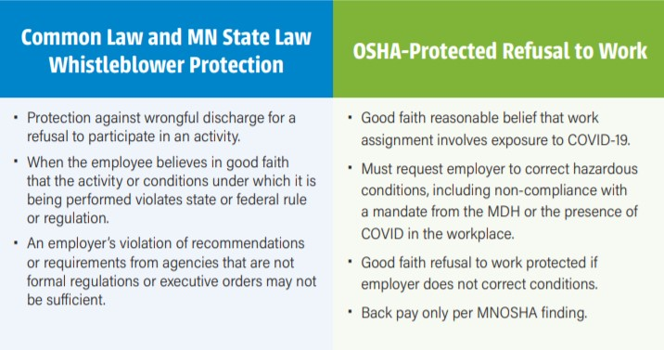
Disclaimer: This publication is for informational purposes only and is not intended as a substitute for specific legal or other professional advice. If you have questions about you or your local’s rights or legal options in a specific situation, please contact your [Insert Field Staff Name} Education Minnesota Field Staff, at [Insert Field Staff email address].

